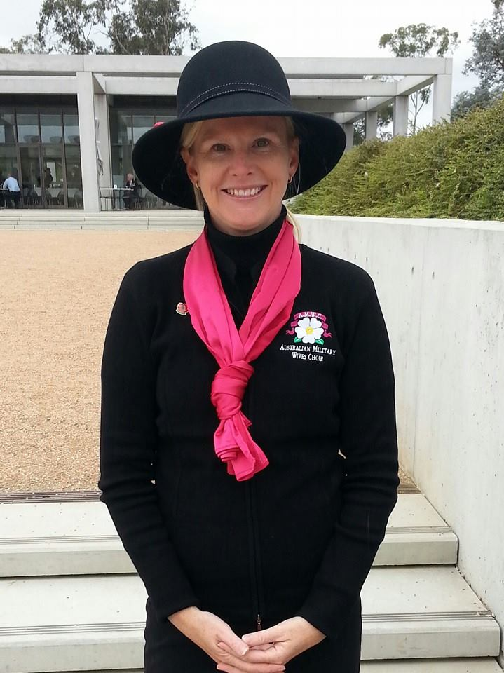
The Australian Military Wives Choir has a strong style that unifies our appearance and our “brand” when out in public. Our uniform helps to identify us to others and creates a cohesive and professional appearance.
The uniform pieces have been carefully selected for their style and versatility to suit a large range of women’s sizes and shapes, and provide suitable clothing options no matter where the choir is located. The uniform is black, with the logo embroidered on the left breast.
Choir members are not required to purchase uniforms, and may participate in all choir performances wearing their own black shirt with black trousers or skirt, and borrow a scarf and hat from the stock held by the choir.
Felt hat, cardigan and scarf, as modelled by one of our choir members.
For members who wish to purchase their own uniform, AMWC has a range of uniform items to choose from, shown below. Prices are current as per March 2015, and include GST and shipping charges
Orders are processed through the AMWC National Publicity Officer using our account with the clothing company; please contact her via email to be added to her regular order: amwc.canberra.publicity@gmail.com or order directly through the website: www.amwchoir.com
Shirts and Cardigan
1. Coolbreeze, collarless short sleeve blouse, black – Item No. GW1583WS
Slim fit that is quite tailored, with pleating at the shoulder and banded sleeves.
Cost: $70.00 (inc. GST and shipping). Available in sizes 6-24.
View details here: http://extranet.gloweave.com/display.asp?page=06&cat=Corporate+2013&stylecolour=1583WS_Black
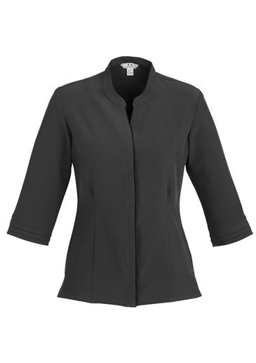
2. Quay Ladies ¾ sleeve Shirt, black – Item No. FBS231LT
A generous cut, which is looser and more free flowing than the short sleeved
shirt. This style is also available in short sleeves if preferred.
Cost: $50.00 (inc. GST and shipping). Available in sizes 6-24.
http://bizcollection.com.au/category/shirts/quay/s231lt

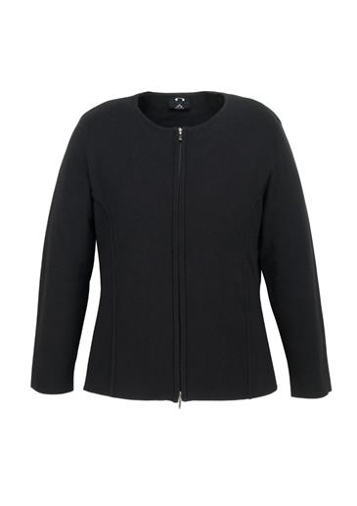
3. Two Way Zip Cardigan, black – Item No. FBLC3505
Soft, warm, and quite stretchy, with a two way zip.
Cost: $67.00 (inc. GST and shipping). Availalble in sizes S – 4XL.
View details here:
http://bizcollection.com.au/category/knitwear/cardigans/lc3505

Hats
As many of our singing engagements have been outside a hat was deemed necessary. There is a black felt hat for choirs in cooler climates, and a black straw version for the choirs in hotter locations. Hats can be purchased directly from the choir if desired, but are also loaned out from choir stock for performances.
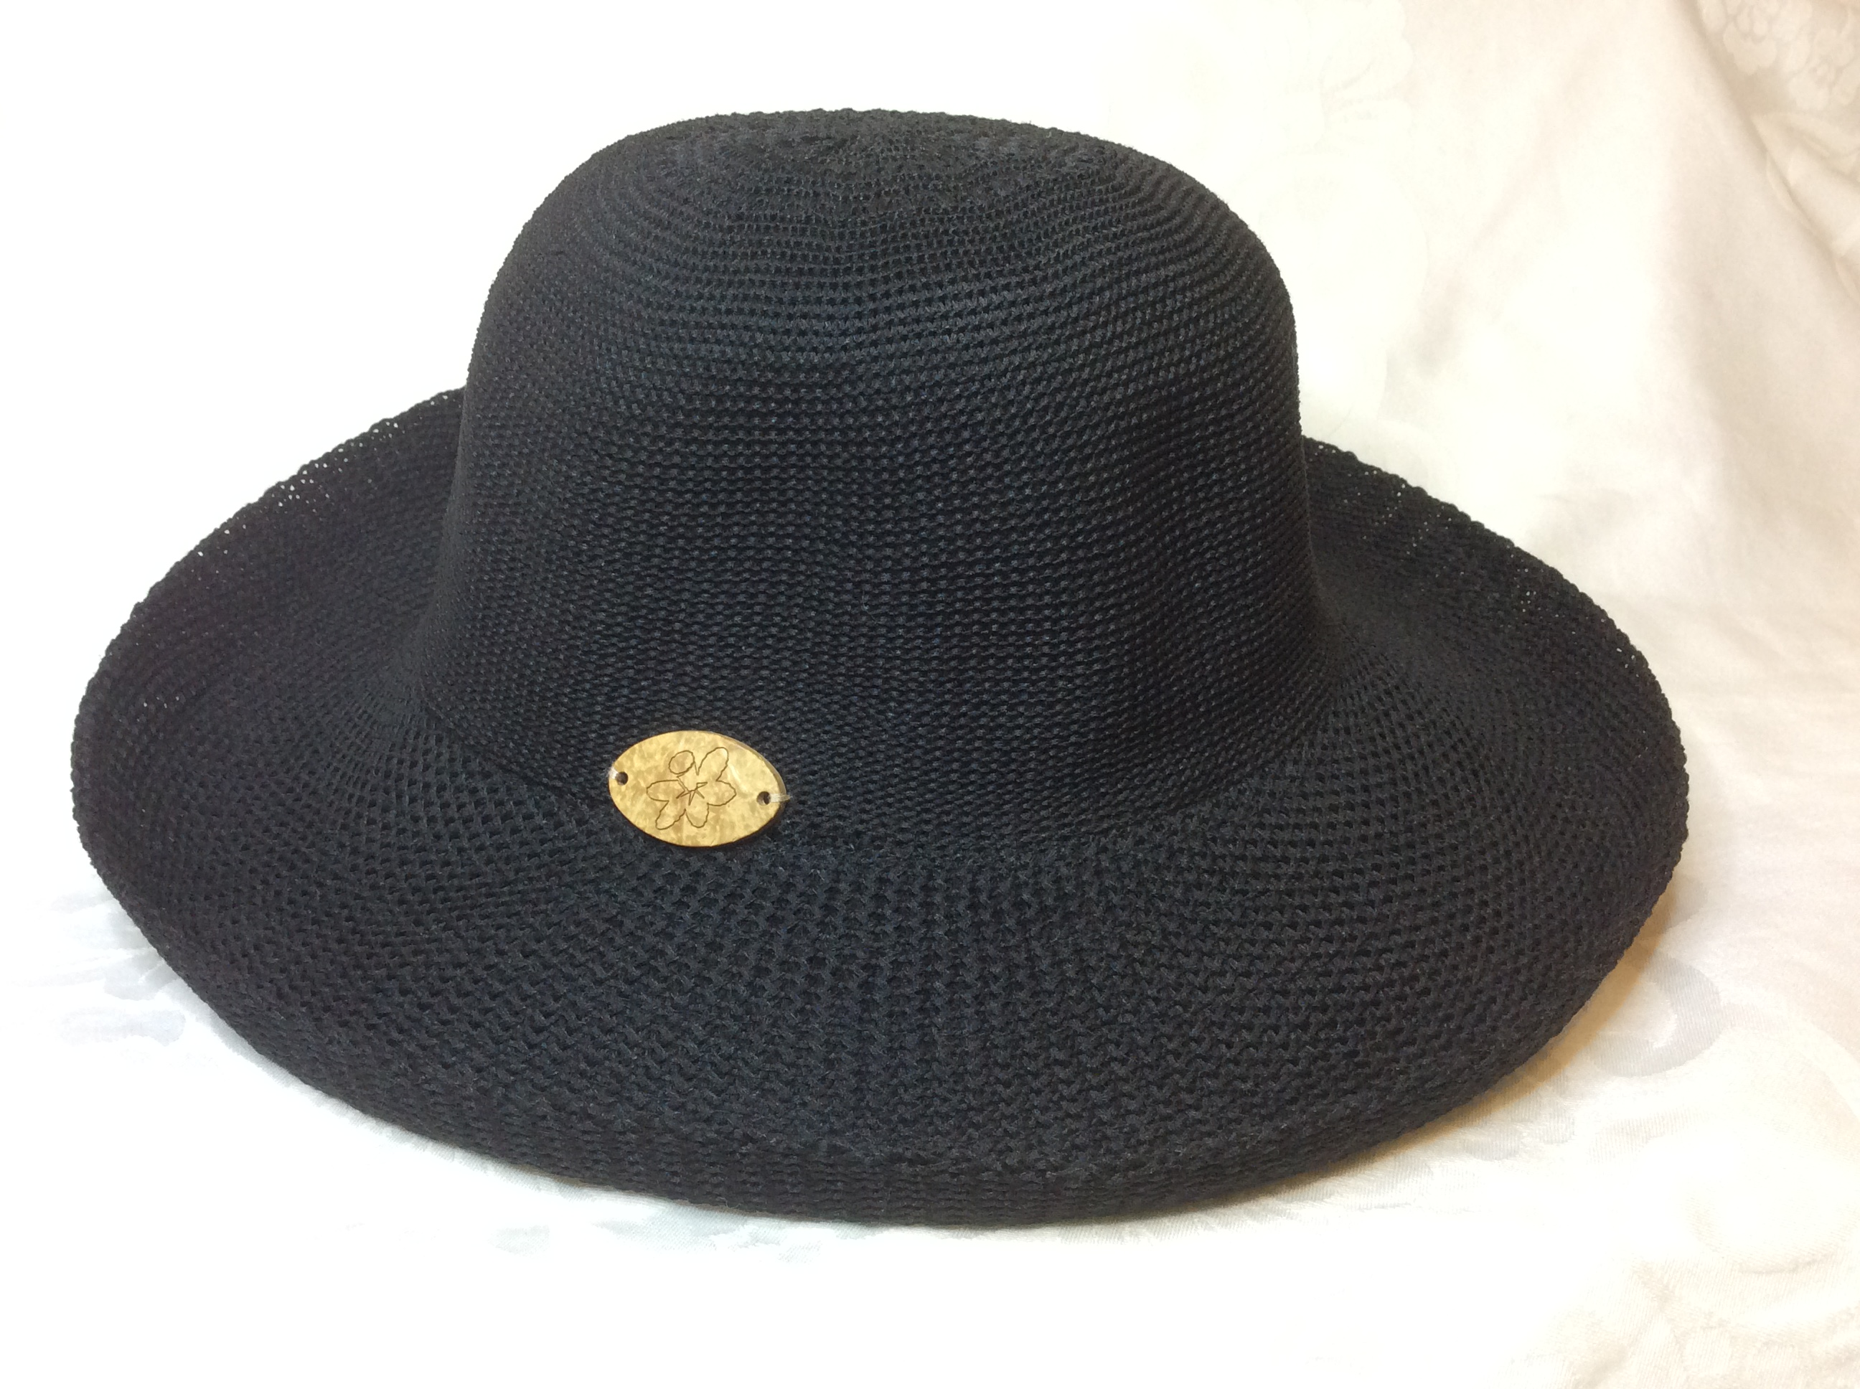
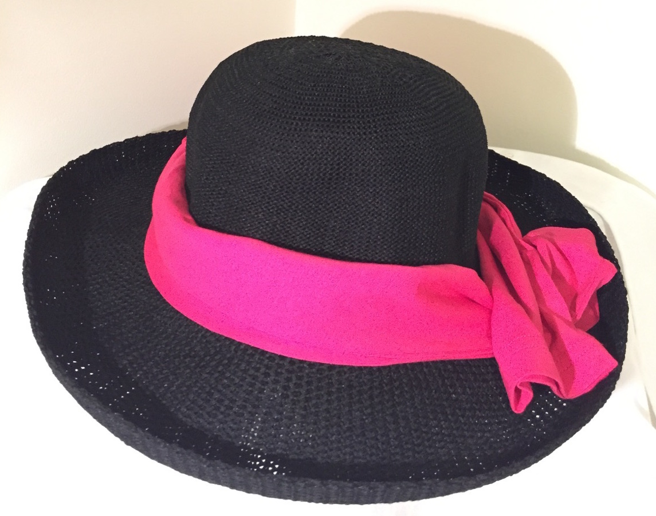
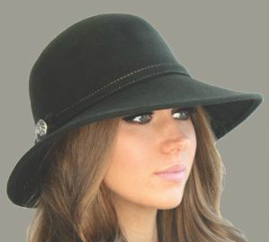

Felt hat Summer hat Summer hat with scarf band
Hats are $25.00 each, one size fits all.
Scarves
Our choir members wear bright pink scarves that stand out beautifully against the black uniforms. These are loaned from the choir and do not need to be purchased.

